1. Use the modes w,r,x,x+.

Step -1: Before starting the code, we need to create a .txt file and write any thing inside of the file.

* **Using with r mode.**

Input:

<?php

$file=fopen("myfile.txt","r");

//here 10 is use for show at lest 10 letters.

echo fread($file,16);

?>

Output:



* **Using with w mode.**

Inside of the myfile.txt have these contents.

AJAX = Asynchronous JavaScript and XML  
CSS = Cascading Style Sheets  
HTML = Hyper Text Markup Language  
PHP = PHP Hypertext Preprocessor  
SQL = Structured Query Language  
SVG = Scalable Vector Graphics  
XML = EXtensible Markup Language

Know performing the w mode.

Input:

<?php

$file=fopen("myfile.txt","w");

//in below line we are write a file content inside of the string.

echo fwrite($file,"hello, How are you");

?>

Output:

After the code we get this.

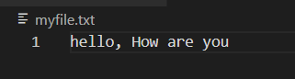

* **Using with x mode.**

If file not exists x mode create a new file with given content see below image. In this image don’t have mypglu.txt file. Let’s see what happened after the code.

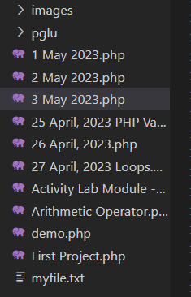

Input:

<?php

$file=fopen("mypglu.txt","x");

//x mode use for create a new file with given contents.

echo fwrite($file,"hello, Use of x mode");

?>

Output:

x mode creates a file with given content.

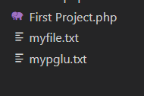

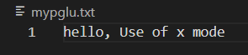

* **Using with x+ mode.**

Input:

<?php

$file=fopen("mypglu.txt","x+");

//x mode use for create a new file with given contents.

echo fwrite($file,"hello, Use of x+ mode with mypglu.txt");

?>

Output:

Create a new file with given name.

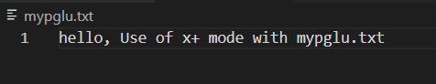

1. Check for directory exists or not of not exists then create a directory.

Input:

<?php

$file="pglu";

if(!file_exists($file)){

    mkdir($file);

}else{

    echo "not found";

}

?>

Output:

Before the code:

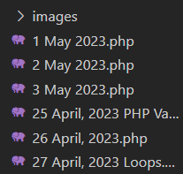

After the code:

